**DAILY ONLINE ACTIVITIES SUMMARY**

|  |  |  |  |  |  |  |  |  |
| --- | --- | --- | --- | --- | --- | --- | --- | --- |
| **Date:** | **19/05/2020** | | | | | **Name:** | **Archana J C** | |
| **Sem & Sec** | **4th A** | | | | | **USN:** | **4AL18CS011** | |
| **Online Test Summary** | | | | | | | | |
| **Subject** | | **Design and analysis of algorithm** | | | | | | |
| **Max. Marks** | | **30** | | **Score** | | | **8** | |
| **Certification Course Summary** | | | | | | | | |
| **Course** | **Python machine learning** | | | | | | | |
| **Certificate Provider** | | | **Great learning academy** | | **Duration** | | | **4-5 days** |
| **Coding Challenges** | | | | | | | | |
| **A user will input two strings, and we find if one of the strings is a sub sequence of the other. Program prints “yes” if either the first string is a sub sequence of the second string or the second string is a sub sequence of the first string.**  **Assume that, the length of the first string is smaller than or equal to the length of the second string.**  **\*\*An expected output of the program:\*\***  **Input the first string**  **tree**  **Input the second string**  **Computer science is awesome**  **YES** | | | | | | | | |
| **Status:Completed** | | | | | | | | |
| **Uploaded the report in Github** | | | | | **Yes** | | | |
| **If yes Repository name** | | | | | **Lockdown coding** | | | |
| **Uploaded the report in slack** | | | | | **Yes** | | | |

Online Test Details: (Attach the snapshot and briefly write the report for the same)

Certification Course Details: (Attach the snapshot and briefly write the report for the same)

Coding Challenges Details: (Attach the snapshot and briefly write the report for the same)

ONLINE TEST : Their was a problem with timing , because of that I’m not able to complete my test.

ONLINE CERTIFICATION : I’m doing python machine learning which provided by great learning academy. I was able to complete upto the introduction about python.

I also done with the python for beginner from Brainovision . Which is about two and half an hour course.

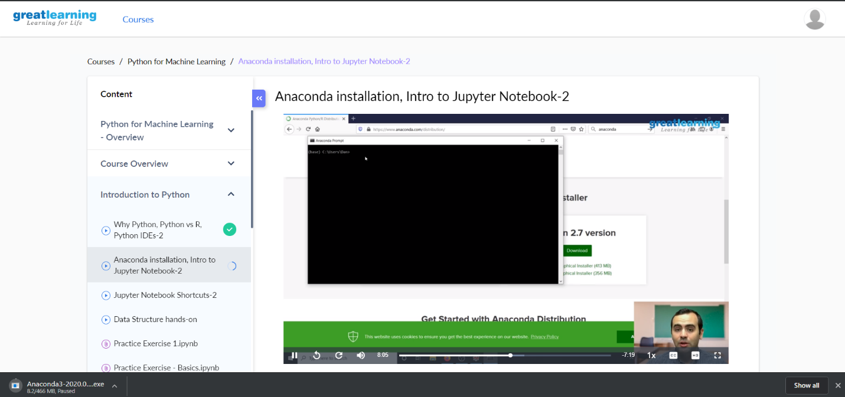

ONLINE CODING : A user will input two strings, and we find if one of the strings is a sub sequence of the other. Program prints “yes” if either the first string is a sub sequence of the second string or the second string is a sub sequence of the first string.

Assume that, the length of the first string is smaller than or equal to the length of the second string.

**An expected output of the program:**

Input the first string

tree

Input the second string

Computer science is awesome

YES

SOLUTION IS UPLOADED TO GITHUB ACCOUNT